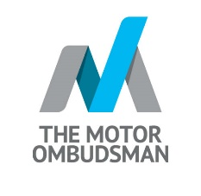
Garage Star Awards example text for customers

Here is some example text you can use to promote the awards to your customers. Please fill out the blocks in yellow with the relevant details for your business.

The Motor Ombudsman’s Garage Star Awards are now open
And you can help us win!

Dear [Customer name],

Here at [Business name] we believe in giving our customers the highest level of customer service and we’re committed to The Motor Ombudsman’s Motor Industry Code of Practice for Service and Repair / and Vehicle Sales.

The Motor Ombudsman’s Garage Star Awards have been designed to recognise the lengths that individuals, and businesses go to, to consistently provide a high standard of service, and to acknowledge the efforts that have been made to keep motorists across the country on the move.

If you think we’ve gone above and beyond during the past 12 months – then we’d be grateful if you could nominate us!

How can you get involved?

Putting us forward for a nomination is easy. You simply need to complete a short form on The Motor Ombudsman’s website, and write up to 250 words on why you think we should win.
You can nominate an individual, or our business as a whole.

And as a thank you for taking part – you will have the opportunity to be entered into a prize draw to win £250 in Lifestyle Vouchers.

You can find out more about how to nominate us here: TheMotorOmbudsman.org/Awards

Thank you for your support,

[Business name]

